WHO CAN NOT COMPLETE THE ONLINE QUESTIONNAIRE CAN USE THIS FILE AND SEND IT BY EMAIL TO: B.MEZZETTI@UNIVPM.IT

ISHS-Strawberry Symposium (ISS2020)
The Polytechnic University of Marche and CREA, in conjunction with the ISHS, have taken the legal and administrative responsibility for organizing this event, with the support of the Rimini Riviera Convention Bureau (for the Symposium event), and MACFRUT International fair (for the Technical Day). The ISS2020 will take place in Rimini, May 3-6, 2020 with guided tours to our Southern (pre-symposium, April 30-May 2) and Northern (post-symposium, May 7-8) production areas and to the Berry School (Ancona, May 7-8).
Being aware of how precious your time is, we would kindly ask for your contribution filling in the following questionnaire. All the collected information will be used to establish the scientific, technical and organizational program of ISS2020.
We aim to start working with the information received by March 31, 2018, but the questionnaire will remain open until December 31, 2018 in order to collect as much information as possible.
Email address:

Congress scientific program
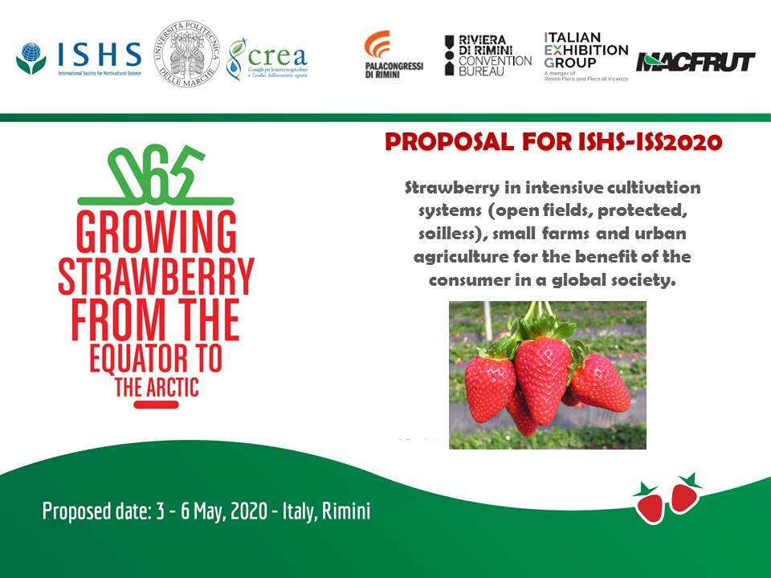

How likely are you to attend each specific topic (“line”) during the Symposium?
BLUE LINE – Plant genotype, phenotype, breeding, biotechnology, physiology, plant adaptation, resilience, nursery, certification, patenting.
Mark only one oval.
    - High
    - Medium
    - Low

GREEN LINE – Cultivation Systems (open field, protected and soilless cultivation), plant nutrition, irrigation and water requirements, climate and light management, programmed production, reducing labour, harvesting technology, increasing quality.
Mark only one oval.
    - High
    - Medium
    - Low

ORANGE LINE – New strawberry pathogens, soil borne and plant pathogens, soil fumigation, IPM/Organic, post-harvest management.
Mark only one oval.
    - High
    - Medium
    - Low

RED LINE – Fruit quality, nutrition, nutraceutical components, local market, processing, industrial products, economical impact, marketing, claims
Mark only one oval.
    - High
    - Medium
    - Low

Specify other topics if needed

Scientific Workshops/Events
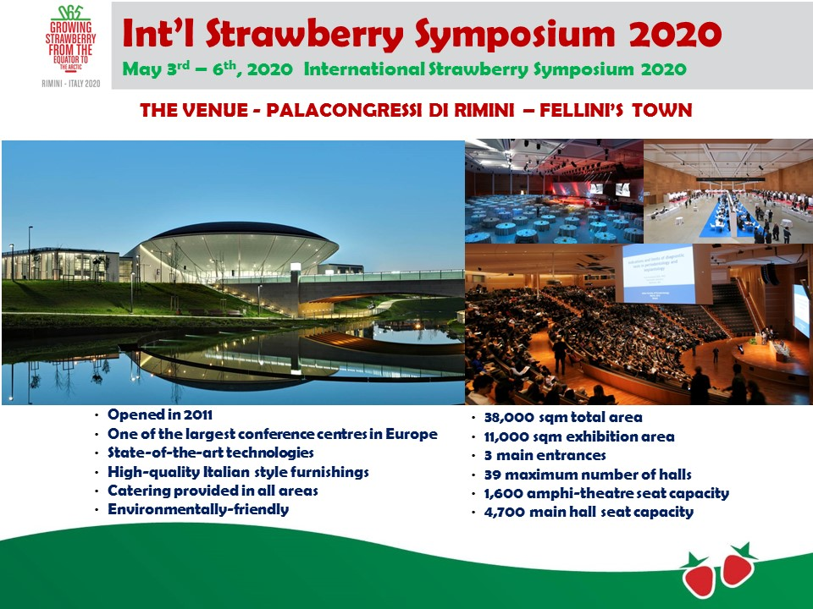

During the Symposium, we could organize afternoon SCIENTIFIC Workshops/Events (max 45-60 min). Express your interest in organizing/coordinating Workshops/Events with the following aims:
Introducing/discussing specific topic – please propose a topic in the space below
Mark only one oval.
    - High
    - Medium
    - Low

Topic:

Promoting new products (e.g. cultivars, chemical product, machine) – please specify the product in the space below.
Mark only one oval.
    - High
    - Medium
    - Low

Product:

Organizing national strawberry meetings – please indicate the country …. (e.g. Germany, Spain, China, Brazil, USA …) management.
Mark only one oval.
    - High
    - Medium
    - Low

Country:

Write your proposal of SCIENTIFIC Workshop/Event

Are you interested in having a booth during the Symposium at Palacongressi Rimini (congress center)? Costs will be communicated and included in the sponsoring program.
Mark only one oval.
    - YES
    - NO

MACFRUT - Professional Fair
One day of the Symposium (May 6) will be organized inside MACFRUT (http://www.macfrut.com/), a professional fair with 25% of visitors from all over the world, more than 1,200 professionals and more than 40 countries representing the five continents. In the 2017 edition, the number of visitors exceeded 39,000. Free entrance, coffee breaks and lunches will be included in the registration fee. Inside MACFRUT fair, a pavilion will be fully dedicated to ISS strawberry exhibitions, space for brief meetings (30-45 min) and dissemination activities will also be available. Express your interest in organizing/coordinating TECHNICAL Workshops/Events with the following aims:
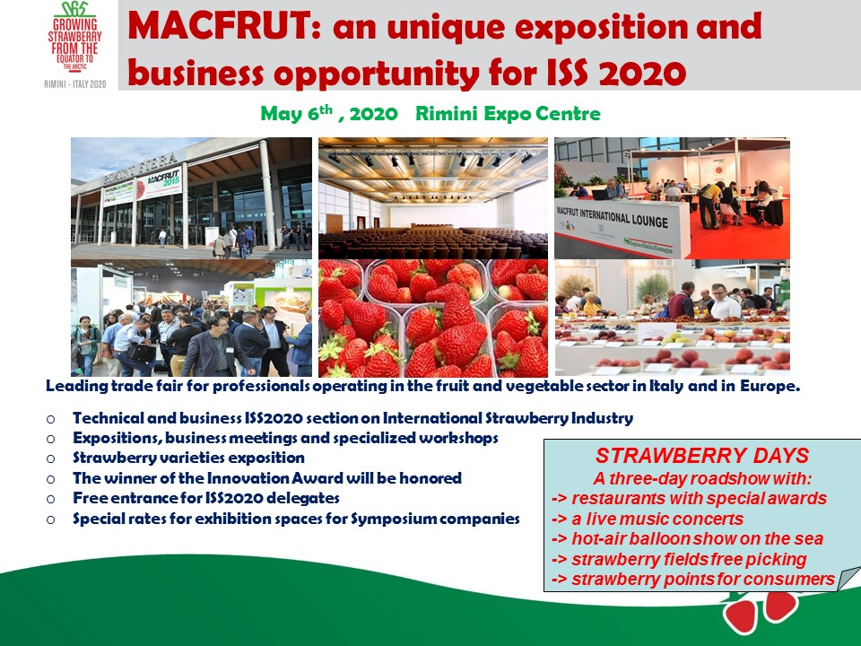
Express your interest in introducing/discussing a technical topic during MACFRUT fair (May 6) - propose the topic in the space below.
Mark only one oval.
    - High
    - Medium
    - Low

Express your interest in introducing new products (eg. Cvs, chemical product, machine) - during MACFRUT fair (May 6) - propose the product in the space below.
Mark only one oval.
    - High
    - Medium
    - Low

Express your interest in organizing a technical national meeting – during MACFRUT fair (May 6) - propose the country (eg. Germany, Spain, China, Brazil, USA …) in the space below.
Mark only one oval.
    - High
    - Medium
    - Low

Are you interested in sponsoring an exhibit at the MACFRUT Strawberry Hall? Booths will be maintained for the entire period of the Fair (May 6 – 8) with open access to all visitors. Costs will be reduced for companies registered for the symposium and booths and sponsors will be advertised in the program.
Mark only one oval.
    - Yes
    - No

Indicate the topic, product or technical meeting you would like to organize

MACFRUT - strawberry fruit exhibition
During MACFRUT we will organize a strawberry fruit exhibition and a “Symposium strawberry variety field” located close to Rimini (Po Valley) comparing several new cultivars coming from private and public breeding programs. Companies interested in having their cultivars included in this demonstration field can send the plants at least 1 or preferably 2 years before, in order to better plan the field. Fruit from this field will also be used for the fruit exhibition that will be organized at MACFRUT
Are you interested in providing fruit for the exhibition?
Mark only one oval.
    - Yes
    - No

Are you interested in testing your cultivar in the ISS2020 Strawberry field?
Mark only one oval.
    - Yes
    - No

Are you interested in visiting the ISS2020 Strawberry field?
Mark only one oval.
    - Yes
    - No

Indicate the number of cultivars you would like to test

Congress Tours
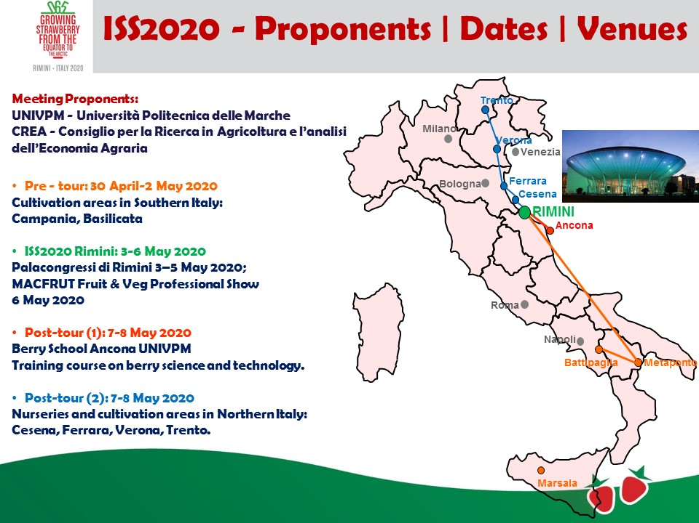

Pre-tour in southern strawberry production areas (April 30- May 2)
Bus pick-up from a Hotel (to be defined) in Naples then visit to Campania and Basilicata strawberry production areas. Costs for the Pre-Tour are not covered by the Symposium registration fee. Therefore, an extra registration fee will be requested, now estimated at about 200€ including bus transport for the tour and transfer to Rimini (6 hours), two-night hotel reservation in Matera (City of Culture in 2019) and lunches.
Tick all that apply.
    - Yes
    - No

Post-tour in northern strawberry production areas (May 7-8)
Bus pick-up from a Hotel in Rimini then visit to Ferrara nurseries, Verona and Trento strawberry production areas. Costs for the Post-Tour are not covered by the Symposium registration fee. Therefore, an extra registration fee will be requested, estimated at 200€ including bus transport from Rimini to Trento and return with stops in Verona and Bologna airports, one night hotel reservation in Verona (City of Culture in 2020) and lunches.
Tick all that apply.
    - Yes
    - No

Berry School
Costs for the Berry School are not covered by the Symposium registration fee. Therefore, an extra registration fee will be requested (now estimated at 150 € covering only access to the school, coffee breaks and 2 lunches). The school will be held at the University campus and will include a visit to the UPM Strawberry breeding field. The program will be defined by the scientific committee. Ancona can be easily reached from Rimini by train – less than one hour. If needed, a group transport can be organized. Are you interested in participating to Berry School?
Tick all that apply.
    - Yes
    - No

Translation services
The symposium will be entirely in English - we can offer translation of the Symposium sections into a different language (eg. German, Spanish, Chinese, other). This service can be offered at a low additional cost, depending on the number of people requesting it. Express your request for translation.
Mark only one oval.
    - Yes
    - No

Indicate Language and number of people for your group.

We can organize group reservation for hotel, restaurant (also for special food) and extra tours.
Do you request hotel group reservation?
Tick all that apply.
    - Yes
    - No

Indicate for how many people.

Do you request restaurant group reservation.
Tick all that apply.
    - Yes
    - No

Indicate type of food.

Do you request extra tour group reservation.
Tick all that apply.
    - Yes
    - No

Indicate number of people and destination.

Gala Dinner and Tours
Express your interest in attending the Gala Dinner and tours for accompanying people. Tours for accompanying people will only be organized during the period of Rimini Symposium and MACFRUT (May 3-6). Many interesting cultural and historical locations are available in this area. Please express your interest in these further destinations: Florence (full day; 2 hours by bus); Bologna (full day; 1 hour by bus); Ravenna (full day; 1 hour by bus); Cesena (half day; 30 min by bus); San Marino (half day; 30 min by bus).
Express your interest in attending the Gala Dinner (we estimate a cost of about 50€ per person).
Mark only one oval.
    - Yes
    - N0

Express your interest in attending tours for accompanying people
Mark only one oval.
    - Yes
    - N0

Awards
In addition to the ISHS Student Awards for best poster and best oral presentations, do you think it would be nice to have other awards such as:
Young scientists
Mark only one oval.
    - High
    - Medium
    - Low

Top scientists
Mark only one oval.
    - High
    - Medium
    - Low

Top technology
Mark only one oval.
    - High
    - Medium
    - Low

Are you interested in sponsoring an award (cost to be defined) ?
Mark only one oval.
    - Yes
    - No

.

Experts

We need to identify experts for the different scientific areas covered by the symposium. We will identify at least 3 to 4 experts for each area. If you are willing to become a member of the Scientific Committee please express your scientific area of expertise:
BLUE LINE – Plant genotype, phenotype, breeding, biotechnology, physiology, plant adaptation, resilience, nursery, certification, patenting.Young scientists
Mark only one oval.
    - High
    - Medium
    - Low

GREEN LINE – Cultivation Systems (open field, protected and soilless cultivation), plant nutrition, irrigation and water requirements, climate and light management, programmed production, reducing labour, harvesting technology, increasing quality
Mark only one oval.
    - High
    - Medium
    - Low

ORANGE LINE – New strawberry pathogens, soil borne and plant pathogens, soil fumigation, IPM/Organic, post-harvest management
Mark only one oval.
    - High
    - Medium
    - Low

RED LINE – Fruit quality, nutrition, nutraceutical components, local market, processing, industrial products, economical impact, marketing, claims.
Mark only one oval.
    - High
    - Medium
    - Low

Indicate your name:

